ML

Basic concepts

What basic algorithms ML has and how to apply these algorithms in daily questions.

Any problem can be typed one of the five below. how machine learning can resolve the problems. The diagram describes the map of ML algorithm with types of questions.

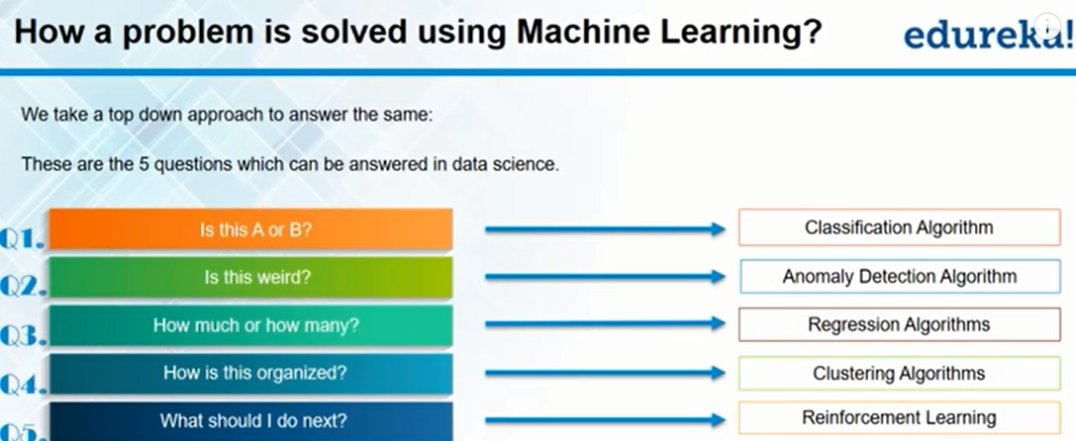

Detail of each algorithms:

. classification algorithms:

It is used for questions which can have only a limited number of answers. When we have only 2 choices, its called 2 class classification. If we have more than 2 choices, its called multi class classification.

. Anomaly detection algorithm

It analyzes a certain pattern and alerts us whenever there is change in the pattern.

. Regression Algorithm

It is used to calculate numeric values. Like how many discount should give the customer? What could be temperature tomorrow.

=====the algorithms above are supervised algorithm

. Clustering algorithm ==🡺unsupervised algorithm. It cannot tell the concrete results. But it can tell the inputs into different groups.

It helps us understand the pattern of the dataset. It separates the data into groups or clusters to ease out the interpretation of the data.

. Reinforcement algorithm

It helps make decision based on previous experience. It works by giving rewards or punishments.

. how to create model and testing

Start from dataset:

Divided data set into 2 parts. One is from training data. the other part is for testing the model.

Feb 20, 2018

Ref: <https://machinelearningmastery.com/basic-concepts-in-machine-learning/>

. prediction

. AI vs ML vs NL

AI is general term. It is not very useful. ML is a method for achieving AI. NL(Neural network) is one of these ways a ML model can predict things.

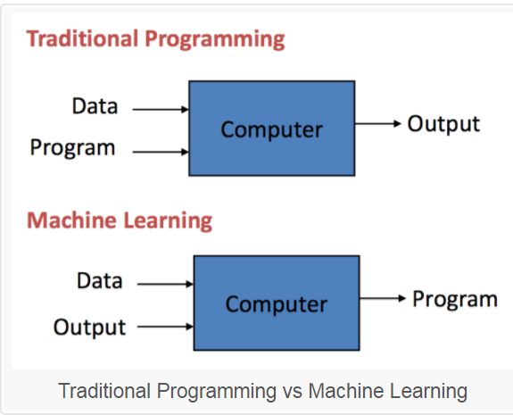

. Key elements of ML

Every ML algorithm has 3 components:

* **Representation**: how to represent knowledge. Examples include decision trees, sets of rules, instances, graphical models, neural networks, support vector machines, model ensembles and others.
* **Evaluation**: the way to evaluate candidate programs (hypotheses). Examples include accuracy, prediction and recall, squared error, likelihood, posterior probability, cost, margin, entropy k-L divergence and others.
* **Optimization**: the way candidate programs are generated known as the search process. For example combinatorial optimization, convex optimization, constrained optimization.